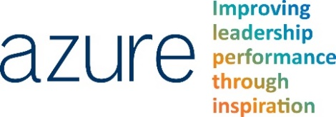
Useful 1-1 Questions

- What is one thing you have accomplished since the last review that you are proud of? – a good ice breaker
- What are you hoping to accomplish over the next quarter, six months and year? – so you can gauge what you feel the employee is capable of
- Do you have access to all the tools and/or resources you need to do your job? If you don’t, what are the roadblocks that are keeping you from getting those tools and/or resources? – management isn’t always aware when employees lack tools or resources
- How well do you and your team work together? What are the problems you are experiencing? – it’s important for management to be aware of problems within a team
- What is one area where you feel like you could improve at your job? Is there anything you feel like I could do to help you improve? – to help you to help the employee get to where they want to be
- What do you think the goals of our company are? What do you think the goals of your department are? – to ensure alignment with wider goals
- How do you feel I have helped you in doing your job? How have I hindered your job performance, what could I do differently to get the most out of you? – chances are management has both helped and hindered, so it can be useful to find out where
- Do you have any concerns that you would like to bring up about your department, or the company? – useful to end with in case concerns not arisen elsewhere

Source: reviewsnap.com

